|  |  |  |  |  |  |  |
| --- | --- | --- | --- | --- | --- | --- |
| A | B | C | QA | QB | QC | Y |
| L | L | L | OFF | OFF | ON | L |
| L | L | H | OFF | OFF | OFF | L |
| L | H | L | OFF | ON | ON | L |
| L | H | H | OFF | ON | OFF | L |
| H | L | L | ON | OFF | ON | H |
| H | L | H | ON | OFF | OFF | L |
| H | H | L | ON | ON | ON | H |
| H | H | H | ON | ON | OFF | H |

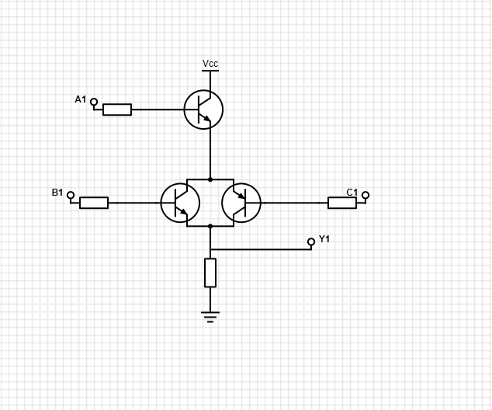

|  |  |  |  |  |  |  |
| --- | --- | --- | --- | --- | --- | --- |
| A | B | C | QA | QB | QC | Y |
| L | L | L | OFF | ON | OFF | H |
| L | L | H | OFF | ON | ON | H |
| L | H | L | OFF | OFF | OFF | H |
| L | H | H | OFF | OFF | ON | H |
| H | L | L | ON | ON | OFF | L |
| H | L | H | ON | ON | ON | L |
| H | H | L | ON | OFF | OFF | H |
| H | H | H | ON | OFF | ON | L |

